<header>

Picture

## “Delivering drop-dead-gorgeous websites that just work.

**At a fair, affordable price.”**

**About us**

# **WEB SITE CREATION**

We deliver website design, digital media production, content marketing, commercial advertising, social media branding, social media marketing and data hosting to business, the education services and community groups within the Bass Coast, Gippsland, Melbourne and across many parts of Australia. Our focus is on highly appealing and user friendly design to promote your business Eye catching graphic design and photographic promotional material for print and online We are available to improve and maintain your current website and social media pages We provide management services for Social Marketing, Online Advertising and Traditional Media campaigns.

## Give us a call to discuss our current special offers

**Features**

## Intuitive Design

IS YOUR CURRENT SITE MOBILE FRIENDLY? WITH THE GROWTH OF SMART PHONES, TABLETS AND GAME CONSOLES ALL CONNECTED TO THE INTERNET YOU NEED TO MAKE SURE THAT YOUR BUSINESS SHINES ON ANY SCREEN SIZE.

**USER EXPERIENCE (OR UX)**

**Ever noticed how some websites just feel right? Natural. Intuitive. It’s no accident. It’s the result of user experience or UX design where everything – from information architecture (IA) and navigation to branding, design and copywriting – are carefully planned by our web designers & developers to create a website experience that engages casual visitors and converts them into paying customers.**

## E-Commerce Solutions

WE PRIDE OURSELVES ON BUILDING VISUALLY EXCITING AND EASY TO EXPLORE E-COMMERCE SOLUTIONS AND USER EXPERIENCES ON ALL DEVICES.

**We make effective use of modern web design software & techniques**

With modern web design software, the tools and techniques for building fantastic, standards-compliant websites need not come at a high price anymore.

**Our operating costs are very low**

All our work is done in-house, never outsourced. We are productive, focused and dedicated to every single one of our website design projects. We deliver on time, and provide top-notch after-sales support

**We are a small business ourselves**

We understand the needs of small business owners who require an online presence but don't want the headache of paying off a website which costs thousands of dollars. You can continue to run your business and leave the website stuff safely to us!

CODE QUALITY TESTING!

Support

## [Logo Design](http://irdesign.com/logo-design.html)

Your company logo represents the product and/or services of your business. There are many important graphic and psychological elements to consider when creating a [Company Logo Design](http://irdesign.com/logo-design.html). What will people think, feel or remember when they see your company logo.

**Services**

**OFFER $50 frontend websites package design for limited number of customers!!**

Unbeatable Features:

* Incredible Value
* Fixed price setup, no "hidden costs"
* Elegant , Interactive websites
* Cross browser compatible
* Search Engine Optimised (SEO)
* 3 Months Website Maintenance (FREE)
* 1 Year Domain Name Registration
* 1 Year Web Hosting Package
* Professional after-sales support
* Be online in 48 OFFER*

**Other**

**URL rewriting**

**Server migration**

### **Some of our amazing clients!**

ANY QUESTIONS? Get in contact!

Sample

<https://www.zimpleweb.com/>

<https://leumesindesign.com.au/>

<https://www.perth-web-design.com.au/>

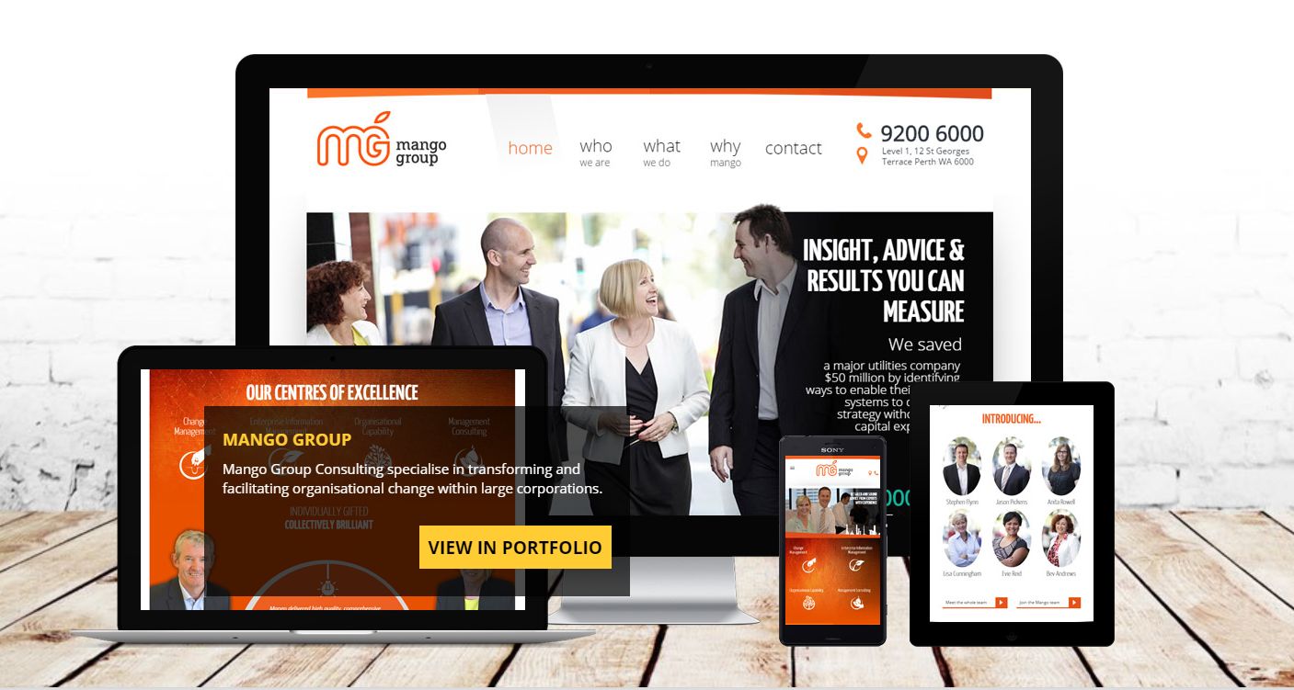

the 11 essentials for a successful website

<https://www.magicdust.com.au/web-design/>

<https://www.wix.com/blog/2017/10/5-design-tips-for-a-professional-site/>

